Skin Colour Segmentation Using Neural Network

**JAYANTH B, VEERESHA N, KIRAN KUMAR G, DHARSHAN BC**

1MS12CS041, CSE, MSRIT, BANGALORE, INDIA

1MS12CS063, CSE, MSRIT, BANGALORE, INDIA

1MS12CS031, CSE, MSRIT, BANGALORE, INDIA

1MS12CS027,CSE, MSRIT, BANGALORE, INDIA

**Abstract**:In this study, using the artificial neural network method of artificial intelligence techniques, using the

pixel values of colour which were obtained from people who belong our data such as RGB (REDGREEN-

BLUE), we realized classification process as the skin or non-skin form of people's image.

There are 3 entries in the artificial neural network. Hidden layers are included in our system. The skin

of the dataset is collected by randomly sampling the R, G, B values from face images of various age

groups (young, middle, and old), race groups (white, black, and Asian), and genders obtained from

FERET database and PAL database

Keywords: ANN, classification, artificial neural network, skin, non-skin, machine learning database, RGB

1. **Introduction**

At present time one of security elements which has great importance for countries is the people's facerecognition system. In such systems, determination of parts whether skin or non-skin will allow foreasier recognition and image processing techniques in computer. Colour space-based models act asefficient approaches for quickly identifying the skin-like regions before performing complicated stepslike face and body detection and tracking. Various colour space-based approaches have beenproposed by researchers. However, skin region segmentation forembedded systems porting needs separate attention because of processing limitations of the devices. Collected skin dataset by randomly sampling B,G,R values from face images ofvarious age groups (young, middle, and old), race groups (White, Black, and Asian), and gendersobtained from FERET database and PAL database (Colour FERET & PAL Face).

Classification can be defined simply as regulation of objects in certain groups based on theirsimilarities. In this study using artificial neural networks was carried out the classification process. InSkin segmentation classification (SSC) process UCI Machine Learning Repository utilizing theclassification of Skin Segmentation data set is made. The aim of this study is to perform theclassification task of data mining and artificial neural network method with information about ourdataset.

1. **DESIGN**
2. ***Design Introduction***

The whole system is built on the Artificial Neural Networks. HADOOP and MapReduce has been made used to implement the normalization of the data set. Coding is done using a programming language known as R on a platform known as R studio

1. ***Architecture Design***

The normalized input data is first split into training set. The model is trained using the training data and tested on

the test data.The results are then compared.

1. ***Detailed Design***

The raw input data is first stored in Hadoop file system. Then, the data is normalized using mapreduce algorithm.

The data is downloaded to the local file system. It is then split into training and testing set. The model is trained using backpropogation network using the training set in R.

The model is applied on the testing set and the results are obtained.

1. **TESTING AND COMPARISON**
2. Regression of Train Set is shown:



1. **Regression of Test Set is shown**:



1. **Confusion Matrix and other results:**

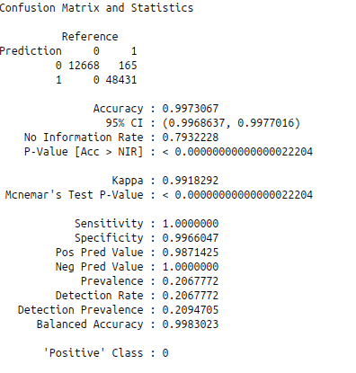

**Application on Face Detection**

We have extended our model for detecting faces in

an image and the results are inserted.

Input Image:

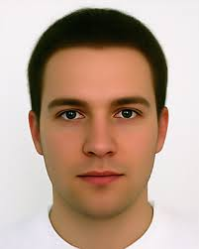

Predicted Image:

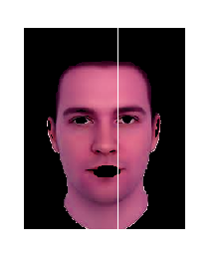

1. **RESULT AND DISCUSSION**

When our study was completed, our system results in our database and rates skin/ non skin comparedwith our system, it is seen that SSC has made a correct estimation of over 99%. From this point ofview, we can say that artificial intelligence techniques show a sufficient success in the classificationprocess of artificial neural networks.

1. **Conclusion**

In this study, artificial neural networks can be used in the classification process and it has been shownthat good results can be obtained. When we look at the results of "Rajan B. Bhatt, Gaurav Sharma,AbhinavDhall, SantanuChaudhury, Efficient Skin Region Segmentation using Low Complexity FuzzyDecision Tree Model IEEE-INDICO 2009, Dec 16-18, Ahmedabad, India, pp. 1-4. "(Rajen et al. 2009)it is seen that we obtained better results than them. While theirperformance is %94.10, in our study the average of validation performance is over %99.

**ACKNOWLEDGMENT**

We would like to sincerely thank our HOD Dr.K.G.Srinivasa for giving us an opportunity to kindle our ideas amd implement it in the form of this project work. We would also like to thank our Professor Sowmya B.J. for giving us valuable inputs for our project work and constantly supporting us in this endeavour.

.

**References**

[1]http://www.ijicic.org/ijicic-11-09028.pdf

[2]https://archive.ics.uci.edu/ml/datasets/Skin+Segment ation

[3]http://nichol.as/papers/Vezhnevets/A%20survey%20on%20pixel-based%20skin%20color%20detection.pdf

[4]http://research.ijcaonline.org/volume38/number9/pxc3876881.pdf

[5]http://ieeexplore.ieee.org/xpls/abs_all.jsp?arnumber=6005689&tag=1

[6]http://www.ajer.org/papers/v2(5)/F0255054.pdf

[7]http://citeseerx.ist.psu.edu/viewdoc/download?doi=10.1.1.457.4990&rep=rep1&type=pdf